Arthur Murillo | TD1

**Timing technology: Beat Saber**

**What is Beat Saber?**

Beat Saber is a rhythm video game in virtual reality developed and published by Beat Games, released in May 2019. The game includes several songs (included in the game or made by other players) with up to five levels of difficulty. In each song, the game presents the player with a stream of blocks synchronized with the notes of the music. The player uses VR motion controllers to wield a pair of lightsabers used to destroy the blocks. Each block is colored red or blue to indicate whether the red or blue saber should be used to destroy it (red for the left and blue for the right) and can be marked with an arrow in one of the eight directions possible (top, top-left, left, bottom-left, bottom, bottom-right, right, top-right). There are also blocks with dots instead of arrows, which players can hit in any direction. When a block is cut by a saber at the right time, it is destroyed, and a score is assigned to the player according to the length and angles of the swing and the precision of the cut.

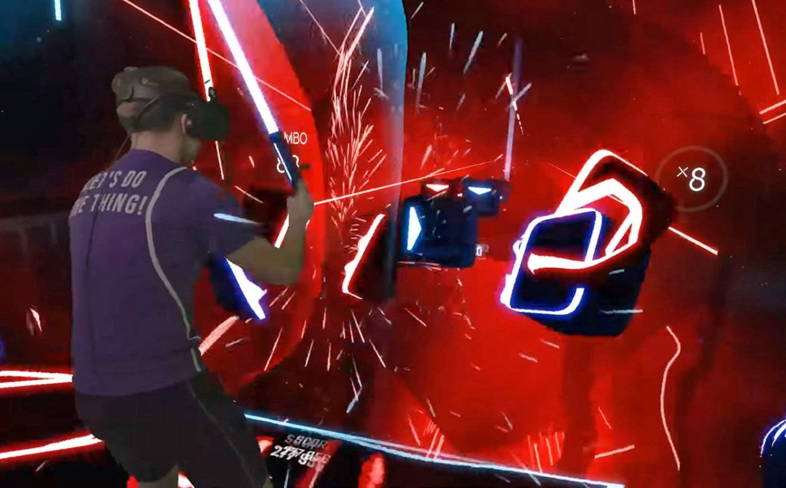

*Someone playing Beat Saber.* [*This link*](https://www.youtube.com/watch?v=3ehSPtWoiuc) *allows you to watch a gameplay video*

**How does the timing technology work in Beat Saber?**

In Beat Saber, the game engine uses the VR motion controllers to determine, at a given time, the position, orientation and velocity of the controller. The controller’s position is determined using tracking devices inside and/or outside the controller, depending on the brand. These devices enable the game to know if the controllers are at the place they are meant to be, at the right time, and other various parameters. On the contrary, the player will not be given any score.

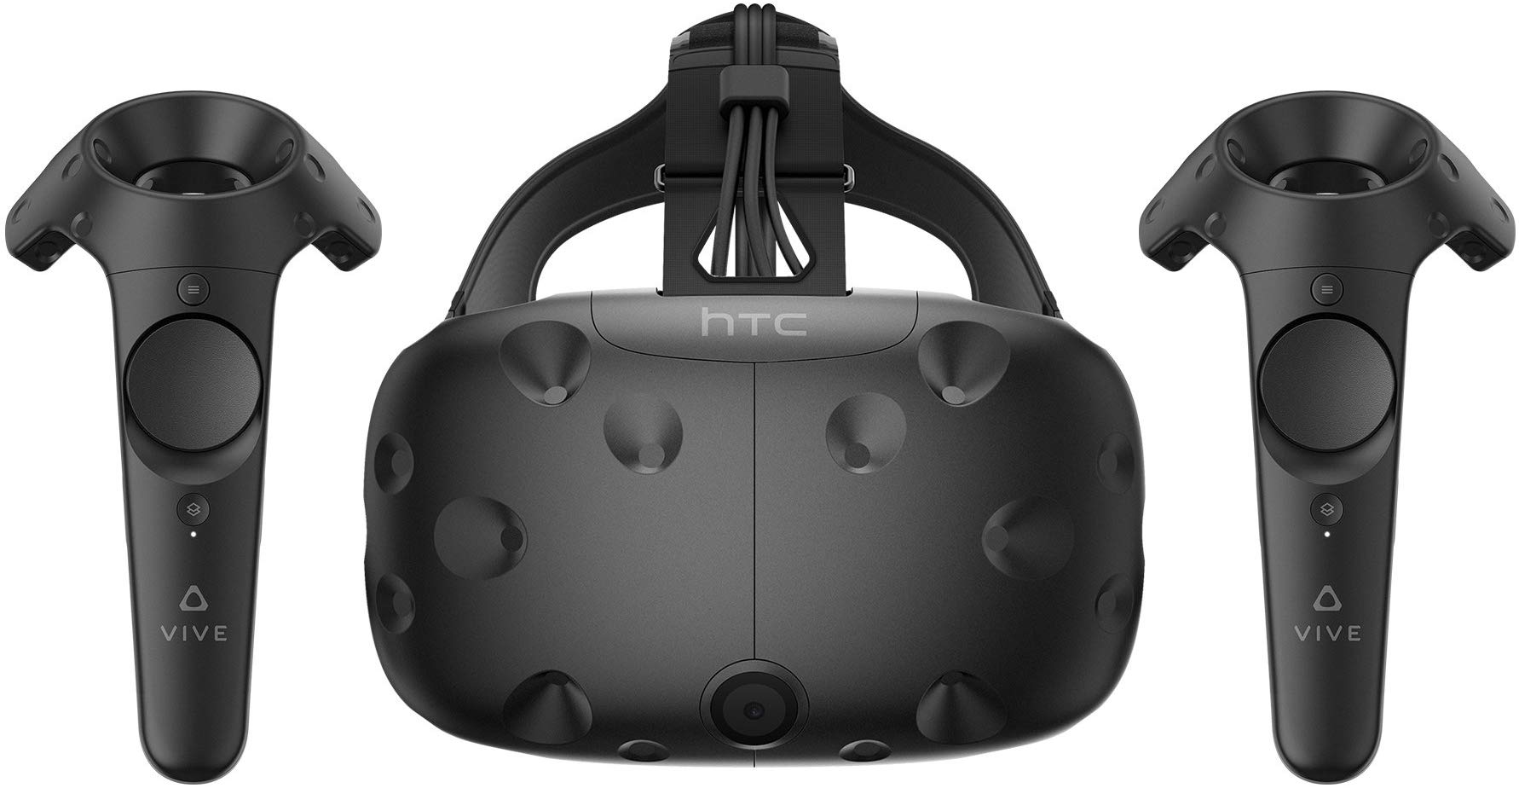

*In this example, the HTC Vive, the tracking device is the headset, and is composed of motion detectors*

**How could Beat Saber used to learn languages?**

I think a good evolution to allow language learning on Beat Saber would be to add a game mode in which the player must perform certain moves if they hear a given word in the song which could be chosen at random or by the player. Let us say the player wants to learn Japanese. The player could select that language in the game settings and the playlist could adapt to that choice. Then, the player would have to choose a category of words like “the family” for instance, and the game would choose a word, or several, in that category and the player would be required to perform a little jump at the mention of the world “お父さん" (the father) or “母” (the mother). Obviously, the player would have to train to recognize the word and the rhythm of the music would have to be slower.

Word count: 441